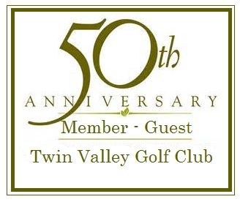Members and Guests:  On behalf of the Twin Valley Golf Club’s Member-Guest Committee, I would like to welcome you to the 2017 Member-Guest Golf Tournament. Many of you are returning participants and know that this is the hallmark Member-Guest event of Twin Valley Country Club. For those who are first-time participants, you are in for a special treat.  Based on player feedback we have devised a special interactive event application that will include each group’s input in format, rules, and prizes.  This Interactive Event Application will request all the traditional information (Page 2), plus it will ask you to choose between optional formats (Page 3), rules (Page 4), and prizes (Page 5). Votes will be tallied on Thursday 5th and formats, rules, and prizes will be announced during Friday night’s Welcome Social. | Please be advised that additional special activities are included, but not mentioned to enhance the tournament’s value.  At Twin Valley Golf Club, we strive to provide the best experience for all players, and we always welcome your feedback. Please contact me mike@twinvalleygolfclub.com with questions or comments.  This is a great opportunity to show your support for the event or market your company to a captive two-day audience. Page 6 details the breakdown of available sponsorships. We appreciate your support and patronage.  “See you at the club!”  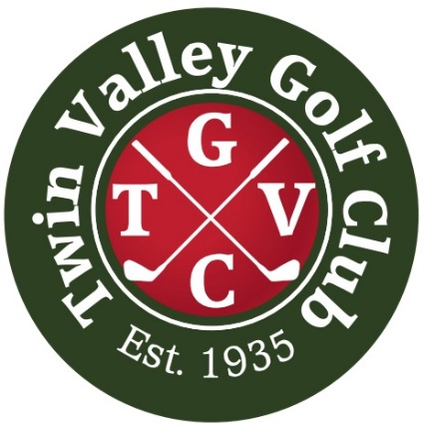  Please remember that all Members are welcome to attend any of the Socials during the Member Guest (Nominal charge applicable).  All applications are due by Wednesday, 4th October 2017. | Schedule of Events  Friday, October 6th, 2017  Practice Round (Optional) Members and their guest play at member’s rate $16.00ea.  Contact Golf Shop at 704.694.2336 to schedule a tee time.  7:00pm Welcome Social  Hors d'oeuvre and music by Geno Marriott (Jazz).  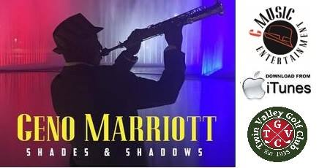  http://www.gmusicgroup.com  Bar will be serving Beer ($2), Wine ($3), Water/Tea @ no charge  Saturday, October 7th, 2017  10:00am Shotgun  Range Opens 8:30am  6:00pm-8:00pm Dinner  Dinner Served 7:00pm  8:00pm Saturday Awards  Closest to the Pins  Longest Drive  Longest Putt  Best Dressed  8:15pm Calcutta  Flights  Bar will be serving Beer ($2), Wine ($3), Water/Tea @ no charge.  Sunday, October 8th, 2017  8:00am-9:00am Breakfast  10:00am Shotgun  Range Opens 8:30am  Awards on 18th Green  Closest to the Pins  Longest Drive  Longest Putt  Flights (Gross & Net)

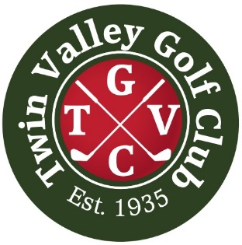
2017 Member-Guest Tournament
October 6th – October 8th
Entry Form

Member Name: __________________________________________

Member Handicap/GHIN Number: ____________________

Daytime Phone: ___________________________________

Guest Name: ____________________________________________

Guest Handicap/GHIN Number: ______________________

Daytime Phone: ___________________________________

City: ____________________ State: _____ Zip: __________

Those without a valid Twin Valley Handicap/Index must submit a copy of his/her Handicap Card or a letter from a Club Professional verifying handicap with this form. All Handicaps will be reviewed and confirmed by the tournament committee. Failure to provide valid proof of handicap will result in the team playing from scratch.

Payment:  Entry fee for team (two Players) | $300.00
Team Guests attending Welcome Social ____ x $15 ea. | $
Team Guests attending Saturday’s Dinner ____ x $25 ea. | $
Team Guests attending Sunday’s Breakfast ____ x $7 ea. | $
Please provide names of Guests/Members attending Socials:
1.
2.
3.
4.

Total Amount Due | $

Please make checks payable to Twin Valley Country Club.
Tournament Entry Deadline is Wednesday, 4th October
Member–Guest Tournament Format
Please note that this begins the interactive event application. There are two decisions that must be made in this section. Initials are used to define vote.

Two-Person Best Ball
"2-Person Best Ball" is a golf format for teams comprised of two golfers. Those two golfers play their own golf balls throughout and the lower score between them on each hole counts as the team score. Net and Gross will be calculated.
RULES OF PLAY
Initial: ____  All USGA rules apply (concession made in fairways - Mark, Clean and Place within “one club length.” Cuts around greens (i.e. Collars) are termed fairways.) | OR | Initial: ____  All USGA rules apply (concession made on whole course - Mark, Clean and Place within “one club length” in same condition. Example - Ball in rough, must stay in rough, ball in bunker, must stay in bunker, etc.…
FLIGHTS
Initial: ____  Determined by initial handicaps.  10-18 teams = 3 flights  19-27 teams = 4 flights  28-32 teams = 5 flights | OR | Initial: ____  Determined by first day of play.  10-18 teams = 3 flights  19-27 teams = 4 flights  28-32 teams = 5 flights

PLAYOFF
Initial: ____  If time and weather permits (Tournament Committee Decision), playoff would begin on hole 18 and continue through the front nine. If Committee decides not to have formal playoff, the winners will be decided by a scorecard playoff (Back-Nine First Via HDCP). | OR | Initial: ____  If time and weather permits (Tournament Committee Decision), playoff would begin on hole 18 and continue through the front nine. Format would change to alternate shot (two golfers play as a team and alternate hitting the same golf ball). If Committee decides not to have formal playoff, the winners will be decided by a scorecard playoff (Back-Nine First Via HDCP).

GROUP (TEAM PLACEMENT)
Teams will be randomly grouped first day of play and paired according to gross position on final day. Starting Holes will be determined randomly on the first day and predetermined on the last day to have lowest gross teams finishing on hole 18.
TEES
Initial: ____  Championship Flight – Blue Tees  Players 64 & Under – White Tees  Players 65 & 69 – Gold Tees  Players 70 & Older – Red Tees  Ladies – Red Tees | OR | Initial: ____  Players 64 & Under – White Tees  Players 65 & 69 – Gold Tees  Players 70 & Older – Red Tees  Ladies – Red Tees
RULES DISPUTES
Rules in question will be decided by the Tournament Committee. Participants that have rule questions are asked to play two balls and score both. The tournament committee (with exclusion of any committee members effected by decision) will announce decision upon completion of the round.
CALCUTTA RULES
SATURDAY NIGHT, ALL PARTICIPATING TEAMS IN THE TOURNEY ARE INDIVIDUALLY PUT UP FOR BIDDING IN AN AUCTION STYLE FORMAT. THE OPENING BID FOR EACH TEAM STARTS OUT AT 50 DOLLARS AND RISES IN 25 DOLLAR INCREMENTS.
ANY PERSON IN THE ROOM, WHETHER THEY ARE PLAYING IN THE TOURNAMENT OR ARE JUST A SPECTATOR IS ELIGIBLE TO BID ON ANY AND ALL OF THE TEAMS. THERE IS NO RESTRICTION ON HOW MUCH THEY CAN BID ON A TEAM AND THERE IS ALSO NO RESTRICTION ON HOW MANY TEAMS THEY ARE ALLOWED TO BID ON.
THE CALCUTTA IS FOR SUNDAY ROUND ONLY AND WILL BE SEPERATED INTO APPLICALE FLIGHTS DEFINED EARLIER.
THE TEAMS PLAYING IN THE TOURNEY ARE ALSO ALLOWED TO BID ON THEMSELVES OR EVEN OTHER TEAMS IN THE TOURNAMENT.
(ONCE A FINAL BID PRICE HAS BEEN DETERMINED ON A TEAM, THAT TEAM HAS THE RIGHT TO BUY HALF OF THEMSELFS AND "SPLIT THE ACTION" WITH THE WINNING BIDDER. For example: IF JOE SPECTATOR WINS THE BID ON A TEAM, THEN HE MUST OFFER THAT TEAM THE OPTION OF BUYING HALF OF THEMSELVES.)
ONCE ALL TEAMS IN THE TOURNAMENT HAVE BEEN BID ON, THE TOTAL IS POOLED AND CALCULATED AND THE FINAL AMOUNT RESULTS IN THE CALCUTTA PRIZE POOL. A TYPICAL CALCUTTA PAYOUT STRUCTURE WOULD RESULT IN THE TOP THREE FINISHING TEAMS IN THE TOURNEY GETTING PAID ON A 50, 30, AND 20 PRIZE POOL PERCENTAGE BASES OR A FIRST AND SECOND PLACE PAYOUT PAID ON A 70-30 % SPLIT.
( REMEMBER; THE TEAM FINSHING IN THE TOP THREE SPOTS WOULD NOT GET PAID ANY OF THE CALCUTTA MONEY UNLESS THEY HAD EITHER WON THE BID FOR THEMSELVES OR HAD BOUGHT HALF OF THEMSELVES FROM THE WINNING BIDDER. OTHERWISE THEY WOULD ONLY BE ELIGIBLE FOR THE REGULAR PAYOUTS FROM THE ACTUAL TOURNAMENT ITSELF).

Member–Guest Tournament Prizes

Saturday:
Closest to the Pins - Merchandise
Longest Drive - Merchandise
Longest Putt - Merchandise
Best Dressed - Merchandise
Low Score Saturday (Flights – First & Second):
Gross – Cash or Merchandise
Net – Cash or Merchandise

Sunday:
Closest to the Pins – Merchandise
Longest Drive - Merchandise
Longest Putt - Merchandise
Worst Score:
Net - Merchandise
Low Score Two Day (Flights - First & Second):
Net – Cash + Name on Club Trophy

*Cash prizes will be determined by participation and sponsorship.
**Our goal is to provide our members and guests with an event that represents the club’s mission.

Twin Valley Golf Club’s Mission
“Creating memories, providing a valued recreational facility to the community, respecting the history and tradition of the game.”

Sponsorship
This is a great opportunity to show your support for the event or market your company to a captive two-day audience. We appreciate your support and patronage.

Sponsor commitment and art must be received by Wednesday 5th. Call 704.694.2336 for more information

Hole Sponsors: | $150 per hole – 2’ x 3’ hole sign and 8” x 10” Scoreboard Sign  Includes 2 tickets to Friday night’s Welcome Social  Hors d'oeuvre and music by Geno Marriott (Jazz).  Bar will be serving Beer ($2), Wine ($3), Water/Tea @ no charge
Scoreboard Sponsor: | $50 – 8”x10” Scoreboard Sign
Beverage Cart Sponsor: | $150 – Sign on Beverage cart plus providing water to participants  Includes 2 tickets to Friday night’s Welcome Social  Hors d'oeuvre and music by Geno Marriott (Jazz).  Bar will be serving Beer ($2), Wine ($3), Water/Tea @ no charge
Silver Sponsor: | $175 – One 2’ x 3’ hole sign and 8” x 10” Scoreboard Sign  Includes 2 tickets to Friday night’s Welcome Social  Hors d'oeuvre and music by Geno Marriott (Jazz).  Bar will be serving Beer ($2), Wine ($3), Water/Tea @ no charge
Gold Sponsor: | $200 – One 2’ x 3’ Hole Sign and 8” x 10” Scoreboard Sign  Includes:  2 tickets to Friday night’s Welcome Social  Hors d'oeuvre and music by Geno Marriott (Jazz).  Bar will be serving Beer ($2), Wine ($3), Water/Tea @ no charge  2 tickets to Saturday night’s Dinner  2 tickets to Sunday’s Breakfast

